**Criterion C: Development**

**Techniques Used**

1 Database Interactions 1

1.1 Firebase Connection 1

1.2 Adding Transactions – IncomeForm Component 2

1.3 Fetching Transactions - RecentTransactionsTable Component 4

1.4 Deleting Categories - CategoryTable Component 6

2 Exception Handling using Asynchronous JavaScript 7

3 Input Validation 8

4 Authentication and Verification 9

5 Abstraction 11

6 Navigation 12

7 Bibliography 14

# 1 Database Interactions

Given the client's requirement that the transactions be accessible in both of his primary devices (Criterion 9), local database solutions (like SQLite, localStorage) were ruled out. Therefore, the use of an online database was considered to be the most appropriate.

For this purpose, Firebase and Firestore (Firestore being a NoSQL database introduced and provided by Firebase) were used in the product as their services were used to effectively fulfil many of the criteria:

* User authentication and application security (Criterion 2) and signing in feature using Gmail accounts (Criterion 1)
* Adding, storing (Criterion 3) and managing (Criterion 5) transactions
* Storing and managing transaction categories (Criterion 6)
* Being able to access transactions on both of the client’s primary devices (Criterion 9)

Firestore’s file-based storage system (shown in Figure 1) facilitates complex querying and high storage scalability for free *(GeeksForGeeks)*, which enabled features such as generating graphs for the Reports page (Criterion 8).

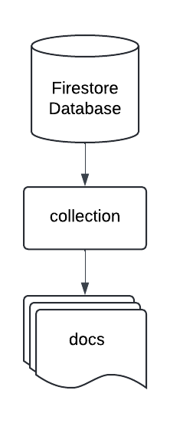

*Figure 1: Firestore stores each transaction and category as individual ‘docs’. These are organized into separate groups called ‘collections’ (as exemplified in Figure 6 below).*

## 1.1 Firebase Connection

The product imports key Firebase and Firestore functions and services through the *firebase.js* configuration file (Figure 3). The functions and services are imported through the Firebase npm package *(Firebase)*.Firestore and Firebases’ features that are used throughout the application are detailed in Figure 2 below:

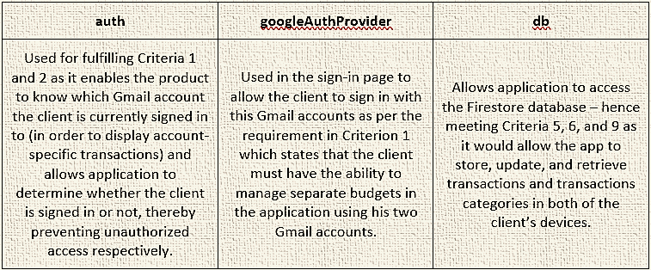

*Figure 2: Important functions imported from the Firebase npm package (Firebase) and/or defined in the firebase.js configuration file (Figure 3, Lines 3, 23, 26).*

*Figure 3: firebase.js configuration file.*

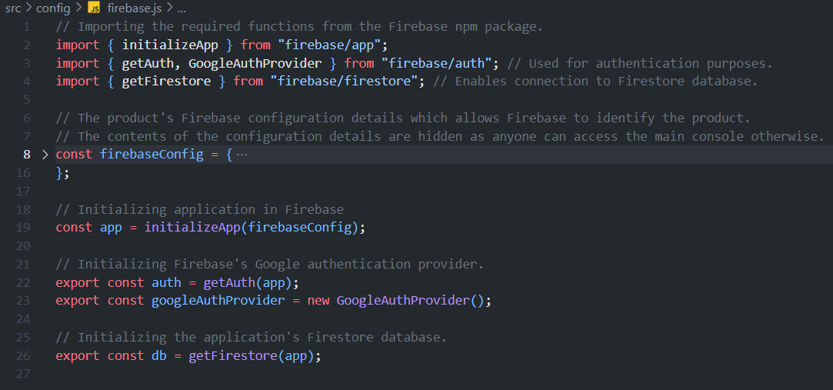

## 1.2 Adding Transactions – IncomeForm Component

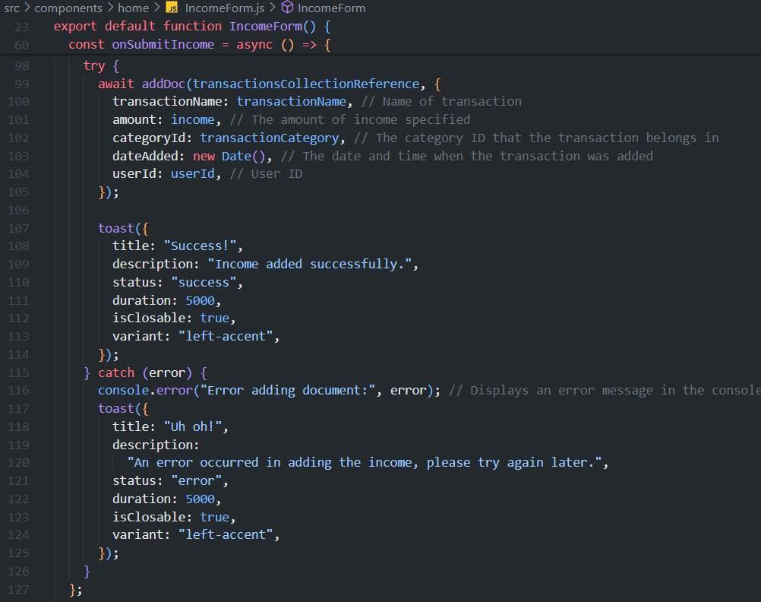

*Figure 4: Lines 99-105 from the IncomeForm.js component file.*

Refers to the ‘transactions’ collection in the database.

There are two types of transactions that the client can add – incomes and expenses – which can be added through the IncomeForm and ExpenseForm components respectively. Both components directly fulfil Criterion 3 by enabling the client to add new incomes and expenses in the home page as shown in Figure 5. The *addDoc* function provided by Firestore *(Firebase)* is used for this function (Figure 4, Line 99) as it sends the to-be-created transaction doc’s field values (Figure 4, Lines 100-104) from the application frontend to the Firestore database to be stored in the ‘transactions’ collection as a new doc (sample income doc shown below in Figure 6). Since the *addDoc* function is asynchronous, it provides extra functionality to the client, as elaborated upon in Section 2.

*Figure 5: Screen capture of the IncomeForm component with filled-in sample transaction data.*

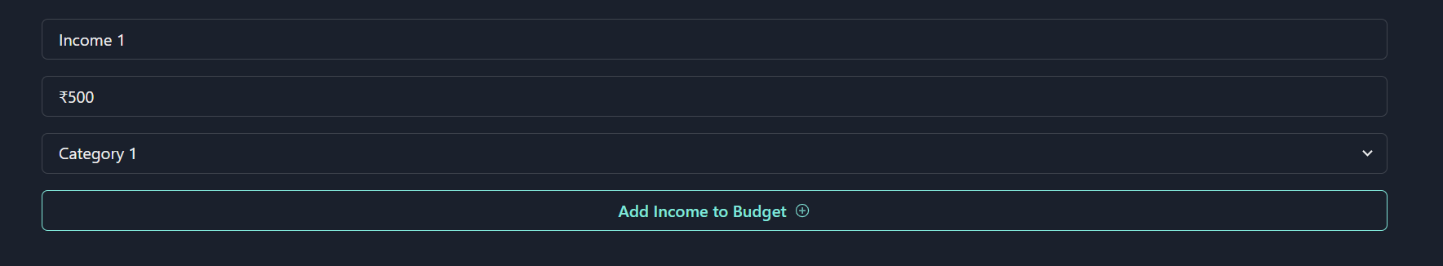

*Figure 6: Screenshot of the structure of the Firestore database. The field values of a sample transaction doc from the ‘transactions’ collection are shown.*

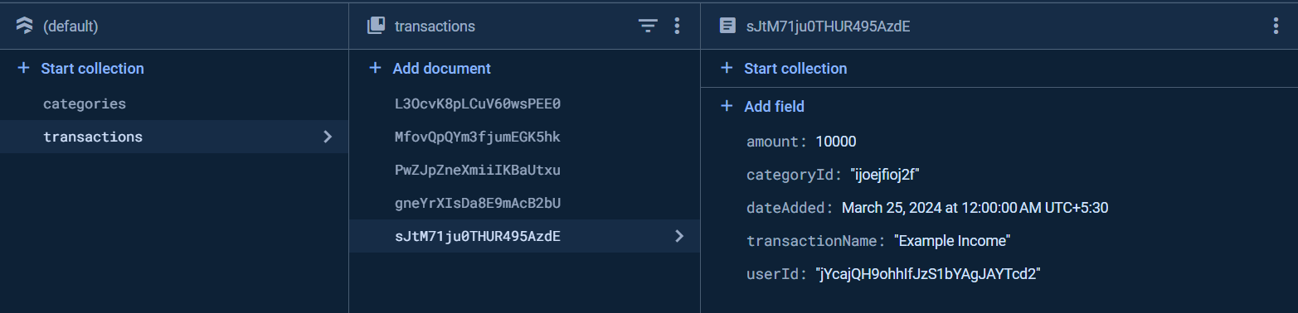

## 1.3 Fetching Transactions - RecentTransactionsTable Component

*Figure 7: Lines 77-106 from the RecentTransactionsTable.js component file.*

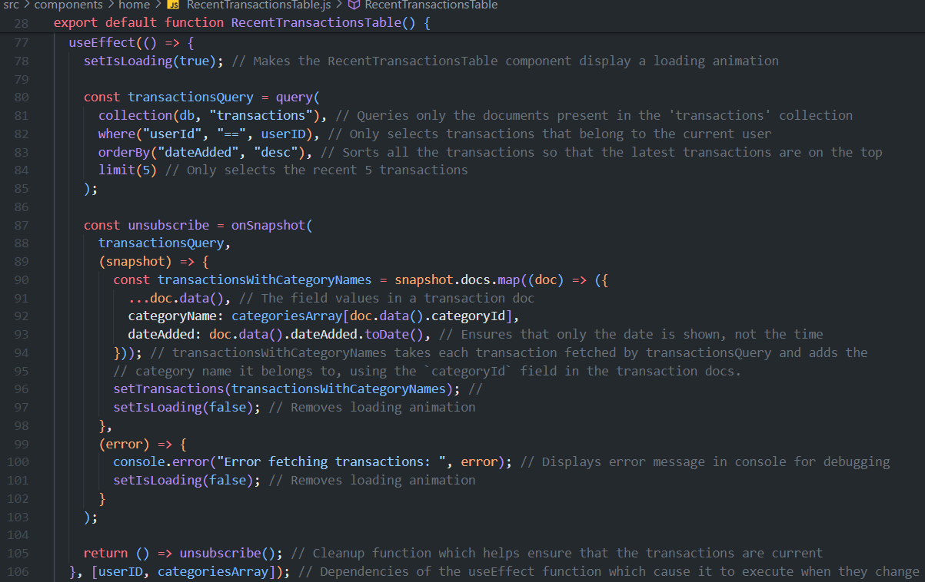

The RecentTransactionsTable component displays the five most recent transactions created by the client in the Home page, which was a problem for the client in his previous setup using Excel (Appendix A1), which also directly meets the requirements set in Criterion 4.

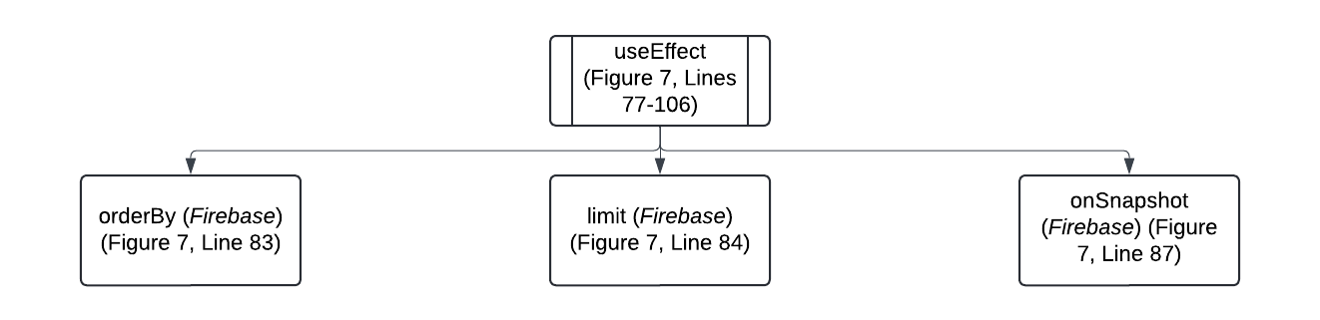

*Figure 8: Process flowchart based on code in Figure 7. useEffect function allows for retrieval of transactions from the database to initiate as early as possible, displaying recent transactions faster and more effectively meet Criterion 4.*

Refers to the ‘categories’ collection in the database.

*Figure 9: Lines 56-65 from the RecentTransactionsTable.js component file.*

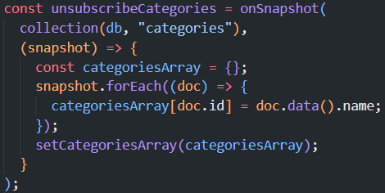

However, the RecentTransactionsTable component needs to obtain the category name associated to the categoryId of each transaction (since each transaction doc only stores the ID of the category to which it belongs (Figure 6)). It is not feasible for the client if he does not know the name of the category which each transaction belongs to. Hence, using the categoryId, the category’s name is fetched from the categoriesArray (Figure 9, Lines 56-65) and displayed in the RecentTransactionsTable (Figure 10), thus contributing to the fulfilment of Criterion 4 since each transaction record can also display the name of the category that the transaction belongs to – hence providing the client more detailed information about his recent transactions.

*Figure 10: Screen capture of the RecentTransactionsTable component with sample transactions.*

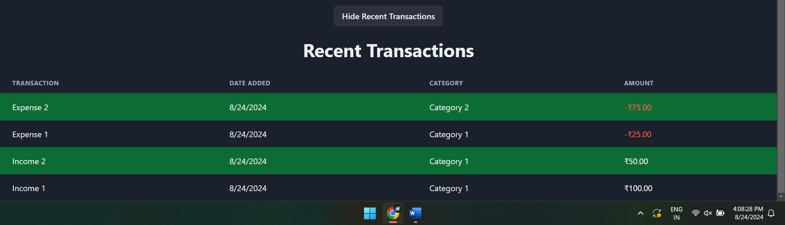

## 1.4 Deleting Categories - CategoryTable Component

*Figure 11: Lines 163-179 from the CategoryTable.js component file.*

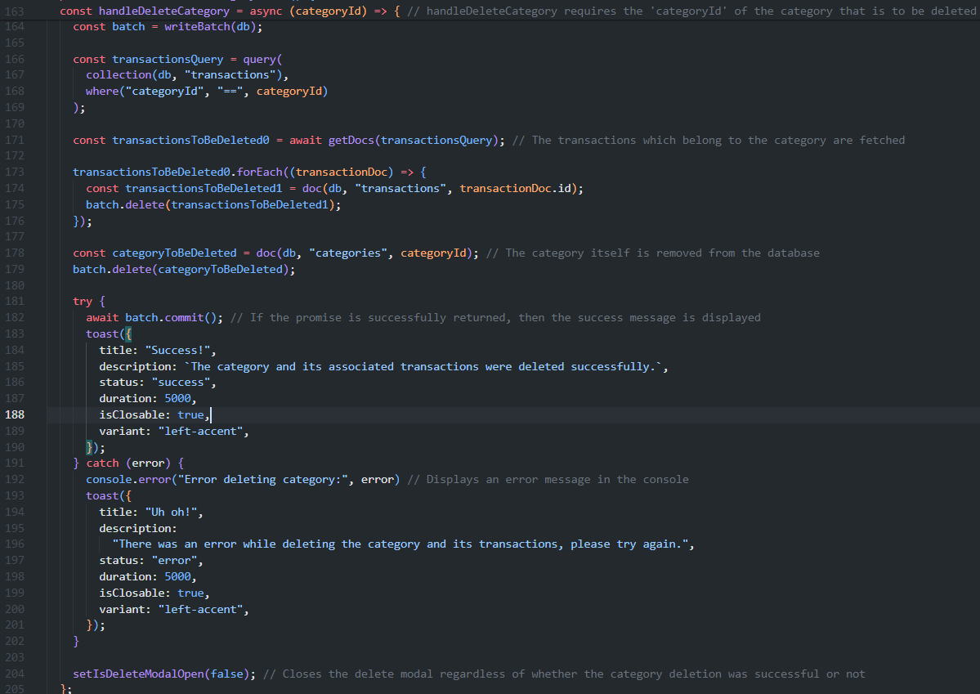

When a category is deleted, all the transactions within it should be deleted as well. For this purpose, Firestore’s *writeBatch* function *(Firebase)* is used (Figure 11, Line 164). This function performs batched delete operations (Figure 11, Lines 175 and 179) to ensure data integrity, which is very important as it holds the client’s vital financial data.

During the batched database operation processes mentioned previously, in the event that the client’s system loses internet connection; experiences a failure; or there is an error in the database itself, the entire process is terminated – this ensures data integrity and hence reduces the chance of errors arising in the database.

Thus, through the *writeBatch* function, the CategoryTable component is able to fulfil an aspect of Criterion 6 – specifically that the client should be able to delete transaction categories. This enables the client to efficiently manage his transaction categories and, in extension, his transactions as well.

*Figure 12: Screen capture of the DeleteTransactionsModal component, which calls the handleDeleteCategory function (Figure 10) in CategoryTable when client clicks on ‘Delete’.*

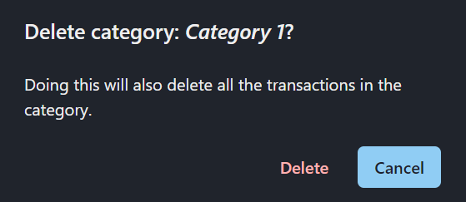

# 2 Exception Handling using Asynchronous JavaScript

*Figure 13: Lines 93-125 from the ExpenseForm.js component file. Some functions are only partially shown for better readability.*

By using asynchronous JavaScript and try-catch blocks, the application is able to manage errors that may arise during database or authentication operations in a graceful manner. This approach is important for fulfilling Criterion 10 as it ensures the client is informed of any issues that may arise during database/authentication operations when he creates, edits or deletes transactions or when he signs-in using one of his Gmail accounts, hence enhancing the client’s accessibility and experience even during events such as network disruptions, system failure, or database/authentication errors.

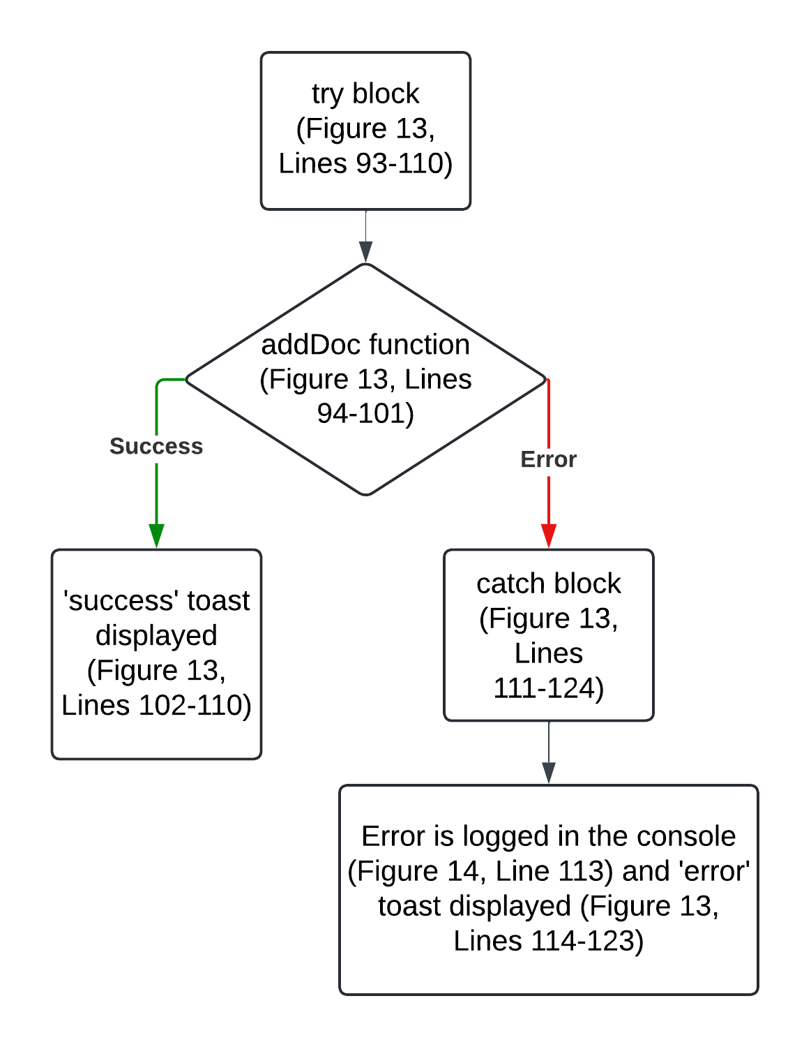

*Figure 14:* *Process flowchart detailing the workings of the exception handling technique (based on the code in Figure 13).*

*Figure 15: Screen captures of the ChakraUI (ChakraUI) “toast” components in the application: ‘success’ (top left), ‘warning’ (top right), and ‘error’ (middle, bottom) status alerts. They improve client experience as discussed above and fulfil Criterion 10.*

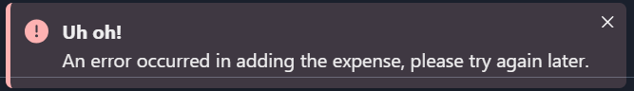

# 3 Input Validation

*Figure 16: Lines 100-111 from the EditTransactionsModal.js component file*

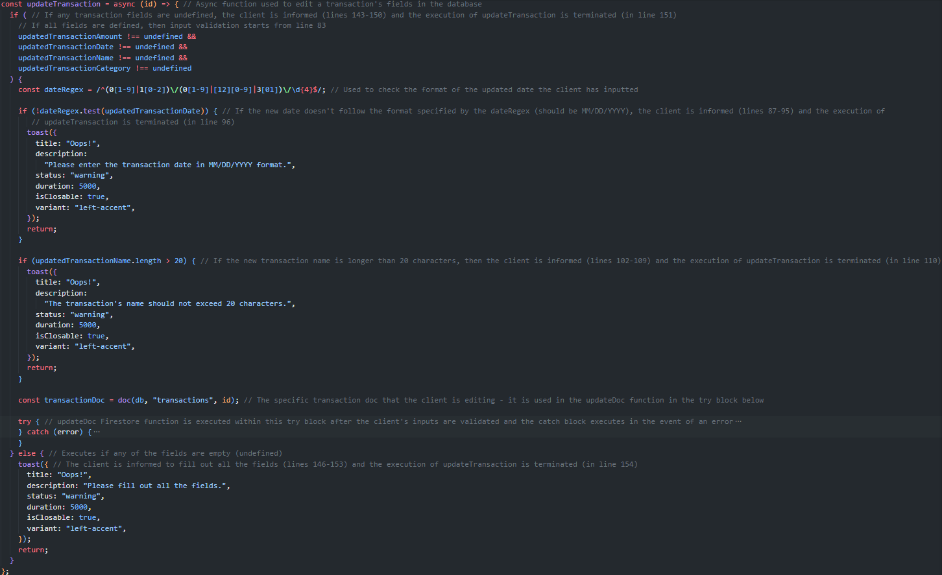

To maintain data integrity within Firestore, input validation techniques are implemented across all transaction and transaction category creating and editing related components. This technique is essential for Criteria 3, 5, and 6, as it ensures that only valid, normal data is entered into the database docs, preventing potential errors or inconsistencies within the database that could disrupt the client’s important finance management processes. Criterion 10 is also fulfilled as client is alerted if a data validation error occurs (Figure 16, Lines 101-109).

*Figure 17: Process flowchart for the input validation of updated transaction names (based on the code in Figure 16).*

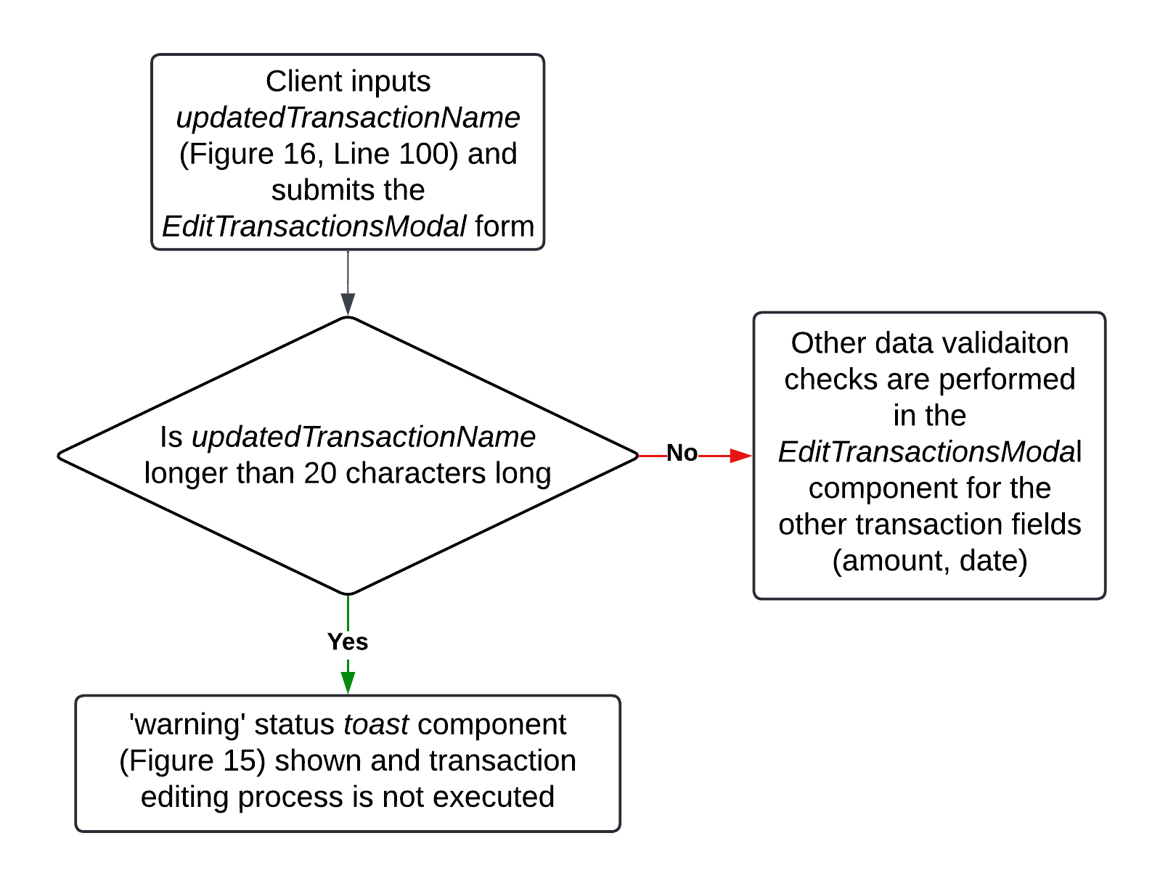

# 4 Authentication and Verification

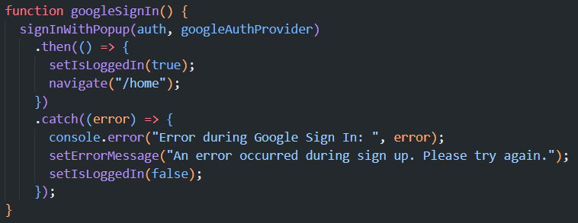

Redirects the client to the Home page on successful sign in

Client is notified if there is an error and the details of the error are given in the console for troubleshooting.

*Figure 18: Lines 26-37 from the SignIn.js page file.*

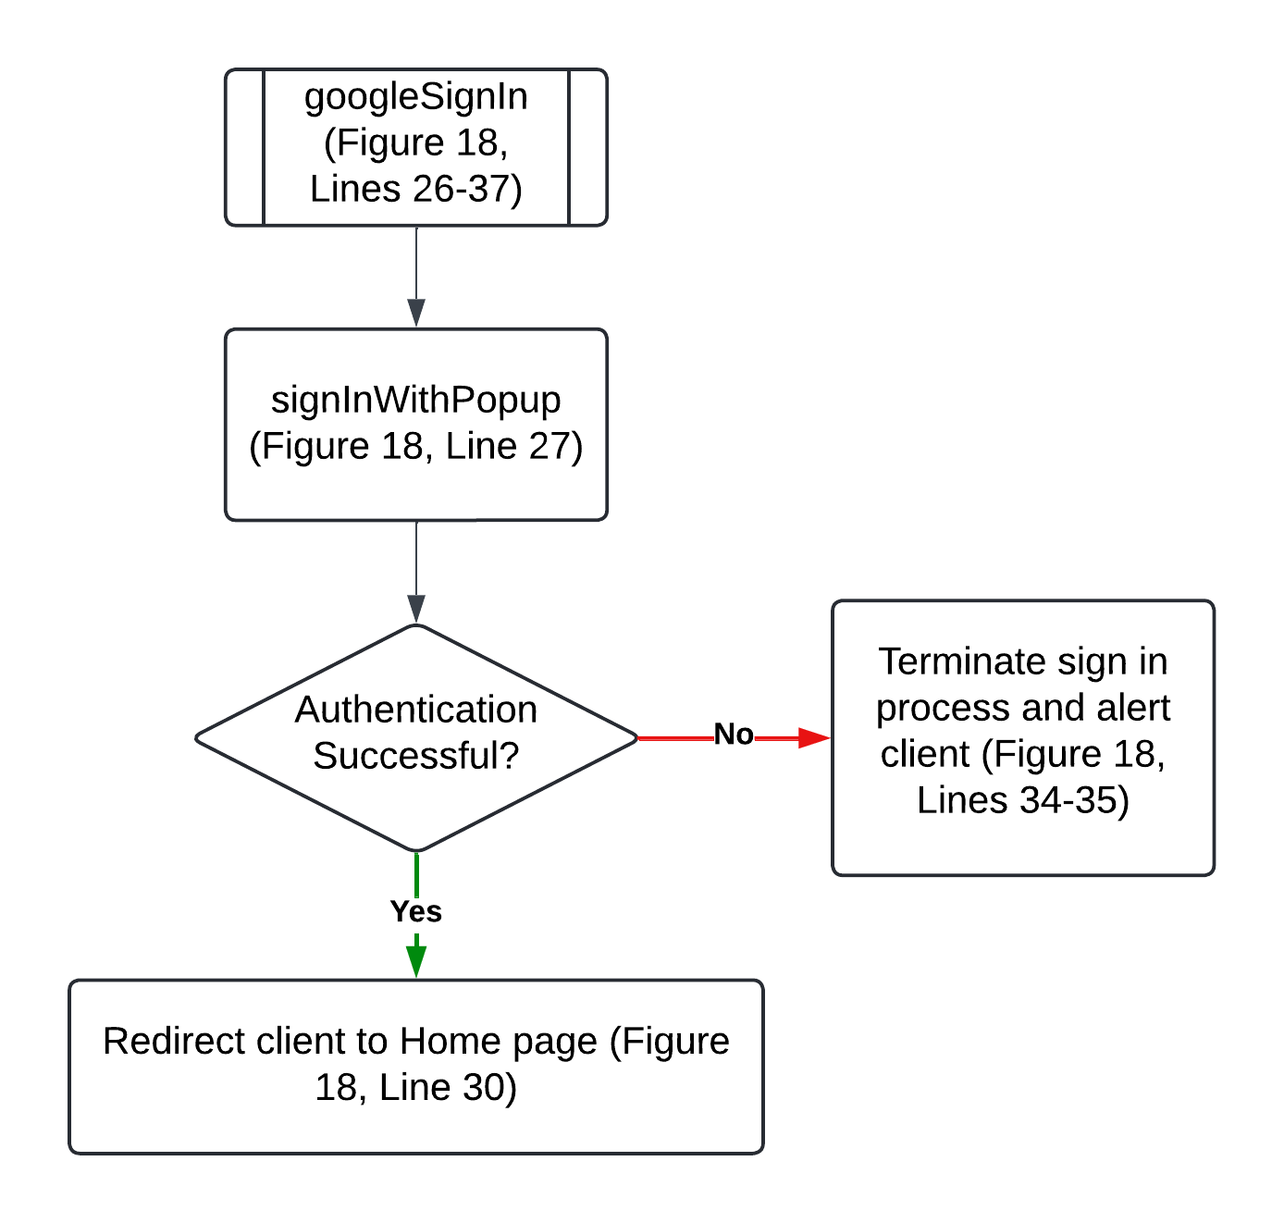

*Figure 19: Process flowchart detailing the workings of the googleSignIn function (based on the code in Figure 18).*

Since the *googleSignIn* function (Figures 18 and 19) displays the official authentication popup (Figure 19) which is displayed in both his Macbook and Windows systems, Mr. Hari can sign into his accounts with a single click on the screen (without having to input his password every time) – this feature is enabled only on his Macbook and Windows desktop as they are his frequently-used devices (however, this could be disabled on his Macbook as his children may gain unauthorized access to the application otherwise as Mr. Hari mentioned (Appendix A1)). This increases the conveniency with which the client can access the application while maintaining a high degree of security, thus further fulfilling Criterion 1, 2, and 9.

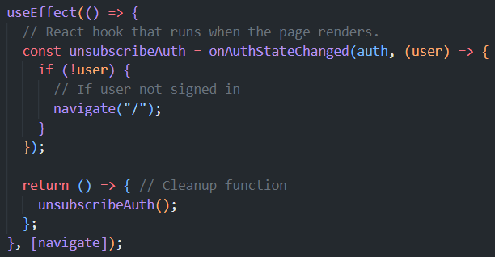

*Figure 20: Lines 27-32 from the Reports.js page file.*

Also, verification checks are done in each page through the Firebase *onAuthStateChanged* function *(Firebase)* (Figure 20, Lines 27-32) to enhance security by preventing unauthorized access to the application when the client is not signed into either one of his accounts – thus contributing to the fulfilment of Criterion 2.

*Figure 21: Firebase stores a list of registered users. The client’s privacy is secured as third-parties cannot access the Firebase console.*

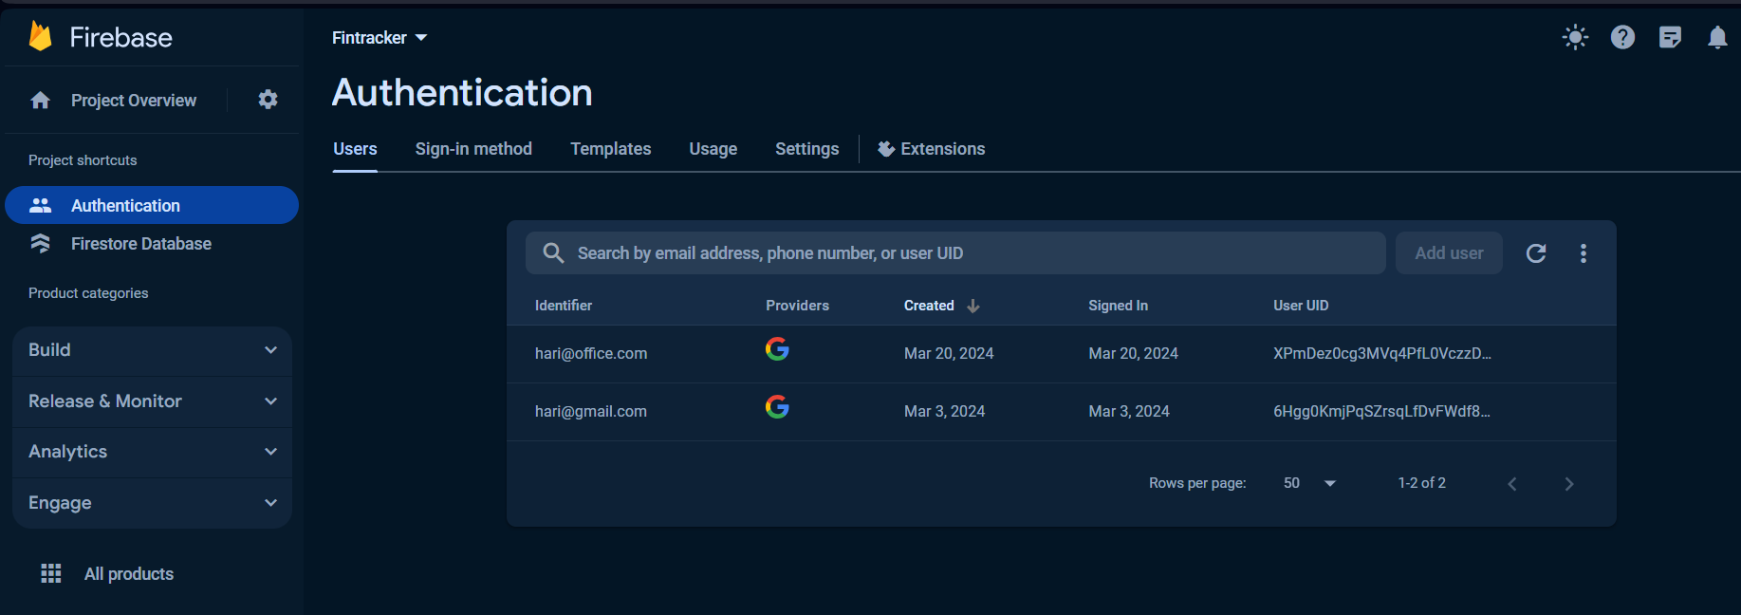

# 

# 5 Abstraction

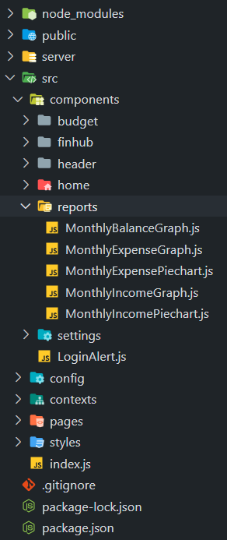

*Figure 22: Hierarchal overview of the modular/component-based structure of the product. The graph and chart component files used in the Reports page are shown.*

In the Reports page, each graph and piechart is rendered through a separate, dedicated component file instead of in the Reports page directly (Figure 22). The component takes in three parameters from the Reports page (Figure 23, Lines 89, 91, 93). One of them – the ‘year’ parameter – is set by the client in the Reports page and is passed on to the MonthlyIncomeGraph component, wherein it is used in the database query (Figure 24, Lines 64-65) to allow the client to see his income reports for specific months within the selected year.

This modular approach allows the client to easily switch the month for each graph independently without having to interact with the entire page, thus simplifying the client interface and enhancing user experience and effectively meeting Criterion 8. Moreover, the maintainability, usability, and scalability of the graph components are improved, hence further contributing to meeting Criterion 8 by enabling easy modifications and updates to the graphical representations of financial data.

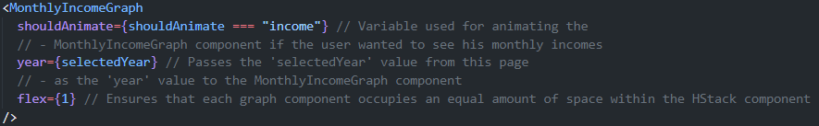

*Figure 23: Lines 88-94 from the Reports.js page file showing the use of abstraction.*

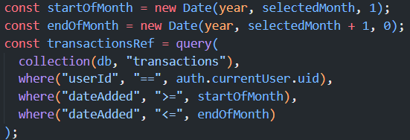

*Figure 24: Lines 64-71 from the MonthlyIncomeGraph.js component file.*

The aforementioned ‘year’ parameter that is passed on from the Reports page

Ensures that only the transactions which belong to the currently signed-in account are shown

These variables filter the transactions which have been created at the starting and ending of the selected month in the selected year

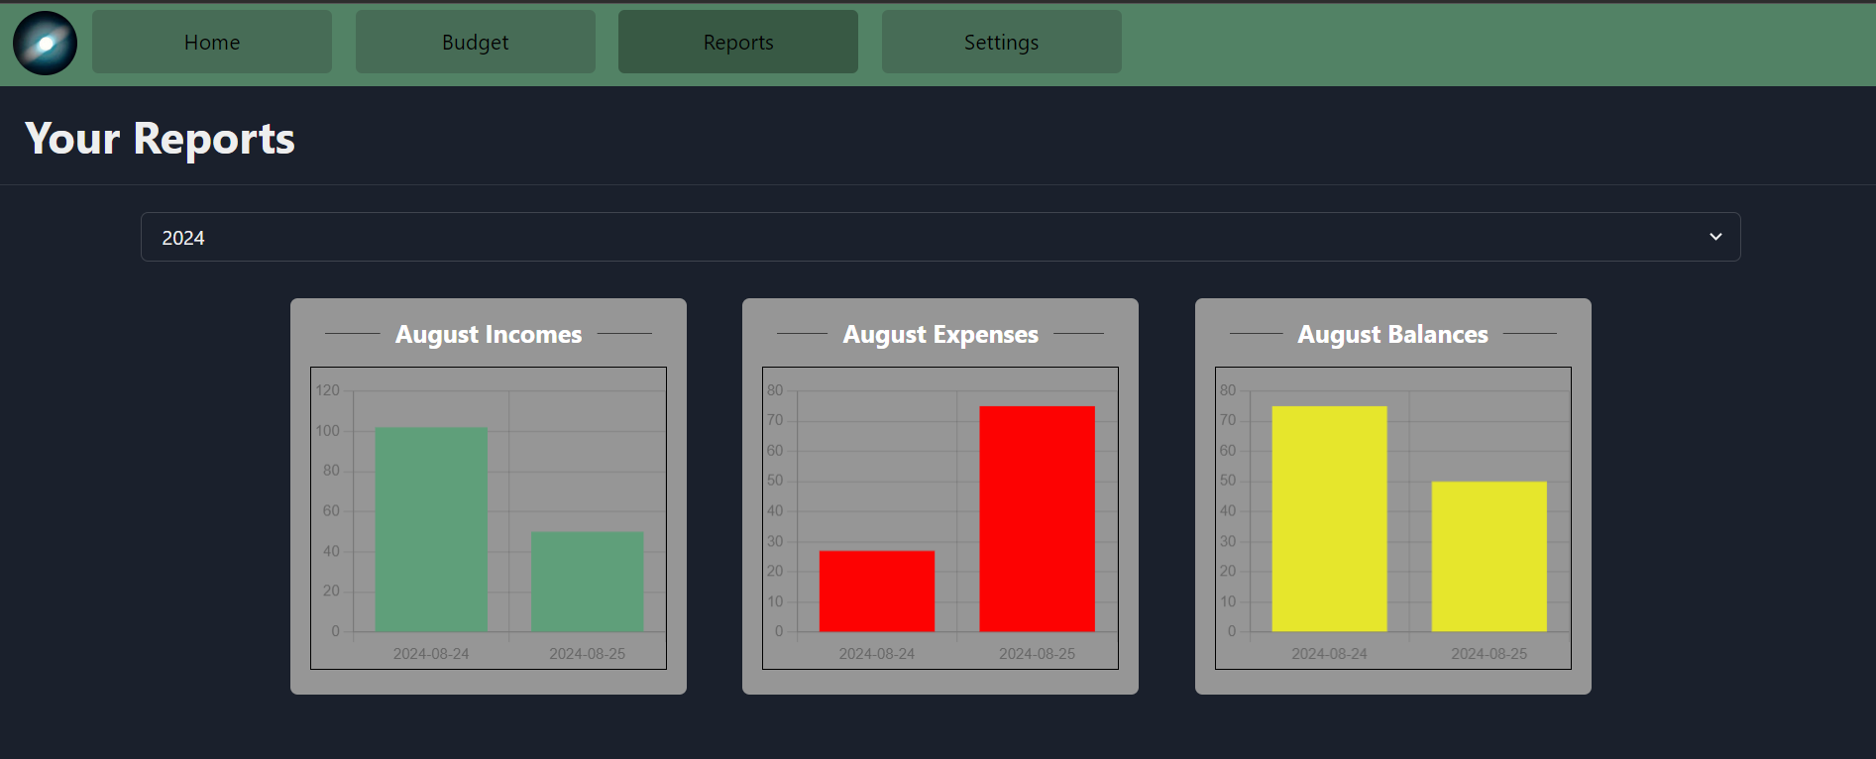

*Figure 25: Partial screen capture of the Reports page. Abstraction was used in the aforementioned graph components in a similar manner as that of in MonthlyIncomeGraph as elaborated upon above.*

MonthlyIncomeGraph

MonthlyExpenseGraph

MonthlyBalanceGraph

Year selector drop-down

# 6 Navigation

*Figure 26: Lines 60-75 from the Header.js component file.*

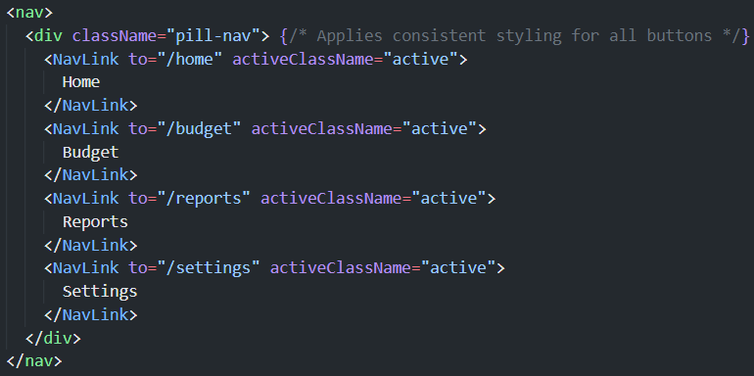

*Figure 27: Screen capture of Header component in the Home page (which is why the ‘Home’ button is darkened, improving client experience and application navigability)*

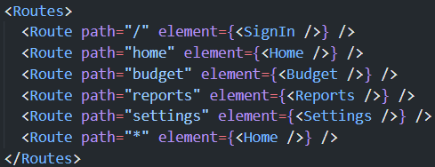

*Figure 28: Lines 15-22 from the index.js main application file.*

The use of the react-router-dom package’s NavLink component *(Dorr and Strickland)* in the Header component (Figure 26, Lines 62-73) streamlines navigation across the application. This is because, when the client clicks on each button/link, the NavLink component redirects them to the requested page. For example, if the client clicks on “Budget”, he is redirected to the “/budget” link (Figure 26, Line 65), which coresponds to the Budget page (Figure 28, Line 18) in application, thus redirecting him to that page.

This contributes to the overall fulfilment of Criteria 3, 4, 6, 7, and 8 as this technique ensures that the client can easily switch between performing his finance management-related tasks, such as adding transactions, filtering and finding specific transactions, viewing graph reports, or managing transaction categories.

Moreover, when the client clicks on the profile picture icon on the far-left in the Header (Figure 27), he can sign out of his current Gmail account and switch to his other account in the SignIn page, thus helping fulfil Criterion 1 (which states that he should be able to switch between his personal and professional Gmail accounts).

**Word count: 1102**

# 7 Bibliography

ChakraUI. *ChakraUI*. n.d. 10 October 2023. <https://v2.chakra-ui.com/>.

Dorr, Tim and Chance Strickland. *react-router-dom*. Vers. 6.22.3. n.d. 24 October 2023. <https://www.npmjs.com/package/react-router-dom>.

Firebase. *firebase*. Vers. 10.9.0. n.d. 5 October 2023. <https://www.npmjs.com/package/firebase>.

GeeksForGeeks. *Firestore and its advantages*. 19 February 2021. 6 October 2023. <https://www.geeksforgeeks.org/firestore-and-its-advantages/>.